HTML
<!DOCTYPE HTML>
<html>
<head>
<title>This is the title</title>
</head>
<body>
<h1>This is the heading</h1>
<p>This is the paragraph tag</p>
</body>
</html>

<!DOCTYPE HTML>
<html>
<body>
<h1>This is the heading</h1>
<h2>This is the heading</h2>
<h3>This is the heading</h3>
<h4>This is the heading</h4>
<h5>This is the heading</h5>
<h6>This is the heading</h6>
</body>
</html>
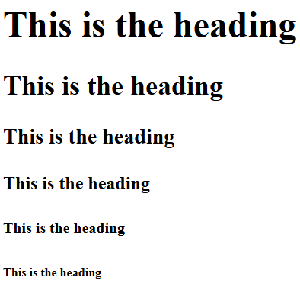
<!DOCTYPE HTML>
<html>
<body>
<h1>This is the heading</h1>
<h2>This is the heading</h2>
<h3>This is the heading</h3>
<h4>This is the heading</h4>
<h5>This is the heading</h5>
<h6>This is the heading</h6>
<h7>This is the heading</h7>
<h8>This is the heading</h8>
</body>
</html>
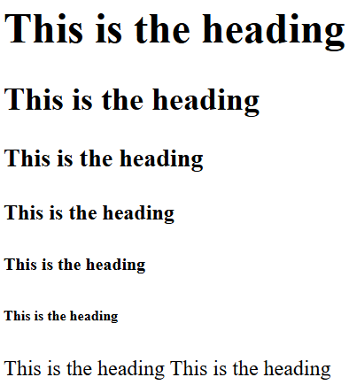

<!DOCTYPE HTML>
<html>
<body>
<h1>This is the heading H1</h1>
<h2>This is the heading H2</h2>
<h3>This is the heading H3</h3>
<h4>This is the heading H4</h4>
<h5>This is the heading H5 </h5>
<h6>This is the heading H6</h6>
<h7>This is the heading H7</h7>
<h8>This is the heading H8</h8>
<p>This is the heading para </p>
</body>
</html>
<!DOCTYPE HTML>
<html>
<body>
<h1>This is the heading</h1>
<h2>This is the heading</h2>
<h3>This is the heading</h3>
<h4>This is the heading</h4>
<h5 style="color:blue;font-size:30px">This is the heading</h5>
<h6 style="font-size:50px">This is the heading</h6>
</body>
</html>
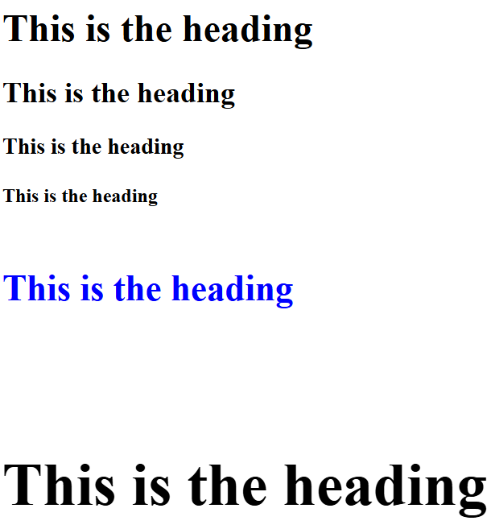
<!DOCTYPE html>
<html>
<body>

<p>This is some text. This is some text. This is some text.</p>
<hr>
<p>This is some text. This is some text. This is some text.</p>

</body>
</html>
<!DOCTYPE html>
<html>
<body>

<p>This is some text. This is some text. This is some text.</p>
<hr style="width:50%;margin-left:100;border: 1px solid blue;">
<p>This is some text. This is some text. This is some text.</p>

</body>
</html>
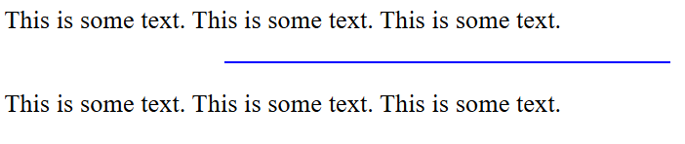
<!DOCTYPE html>
<html>
<body>

<p>lorem10</p>

</body>
</html>
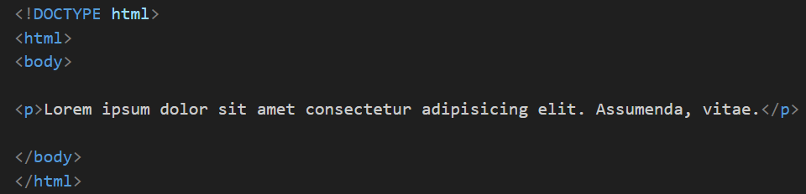
<!DOCTYPE HTML>
<html>
<body>
<a href="https://www.wikipedia.org">Wikipedia</a>
</body>
</html>

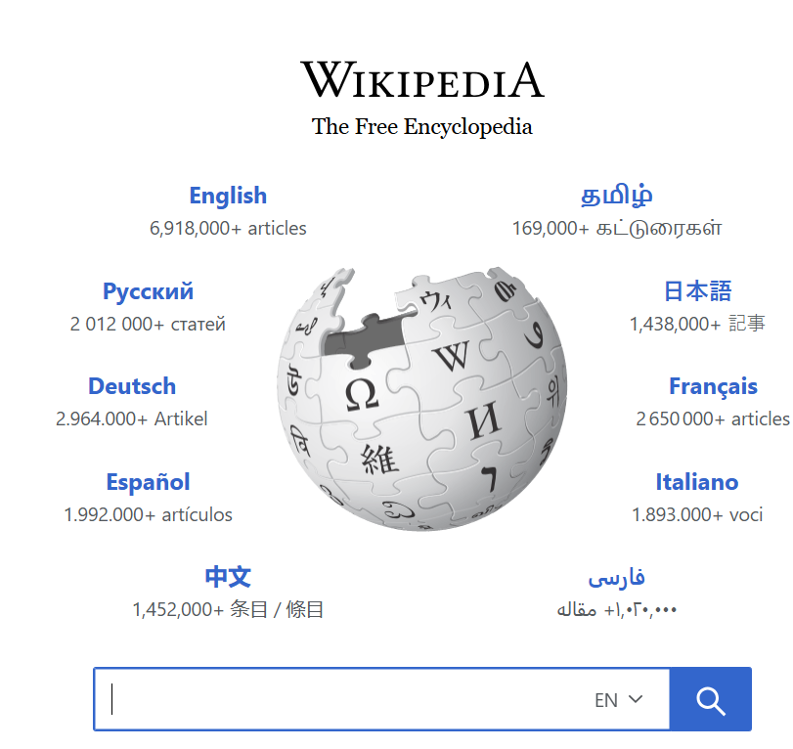
<!DOCTYPE HTML>
<html>
<body>
<img src="D:\Win Sem 25 - 26\Web Programming\demo\bird.jpg" alt="bird image" width=400" height=275">
</body>
</html>


<!DOCTYPE HTML>
<!DOCTYPE html>
<html>
<body>

<h2>HTML Image</h2>
<img src="pic_trulli.jpg" alt="Trulli" width="500" height="333">

</body>
</html>

<!DOCTYPE html>
<html>
<body>

<p>
This paragraph
contains a lot of lines
in the source code,
but the browser
ignores it.
</p>

<p>
This paragraph
contains a lot of spaces
in the source code,
but the browser
ignores it.
</p>
<p>
The number of lines in a paragraph depends on the size of the browser window. If you resize the browser window, the number of lines in this paragraph will change.
</p>
</body>
</html>
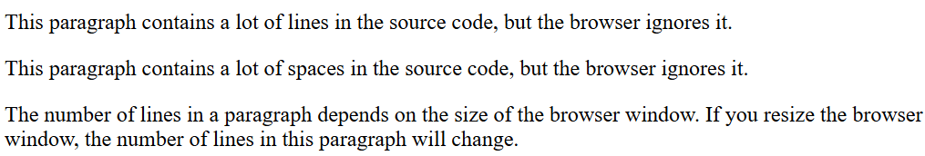
<!DOCTYPE html>
<html>
<body>

<pre>
This paragraph
contains a lot of lines
in the source code,
but the browser
ignores it.
</pre>

<pre>
This paragraph
contains a lot of spaces
in the source code,
but the browser
ignores it.
</pre>
</body>
</html>
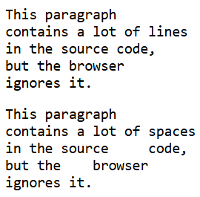
<!DOCTYPE html>
<html>
<body>

<p><b>This text is bold</b></p>
<p><i>This text is italic</i></p>
<p>This is<sub> subscript</sub> and <sup>superscript</sup></p>
<p>Do not forget to buy <mark>milk</mark> today.</p>
<p>My favorite color is <del>blue</del> <ins>red</ins></p>

</body>
</html>
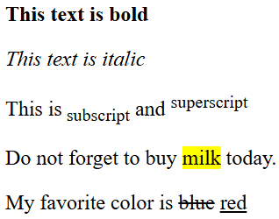
<!DOCTYPE html>
<html>
<head>
<title>என் முதல் HTML பக்கம்</title>
</head>
<body>
<h1>வணக்கம் லெனிநிஷா!</h1>
<p>இது என் முதல் HTML பக்கம்.</p>
</body>
</html>

வணக்கம் லெனிநிஷா!
இது என் முதல் HTML பக்கம்.

<!DOCTYPE html>
<html>
<body>

<marquee>
<h1> Web programming is fun to learn </h1>

</body>
</html>
<!DOCTYPE html>
<html>
<body>

<marquee direction="left"> I'm moving from right to left </marquee>
<marquee direction="right"> I'm moving from left to right</marquee>

</body>
</html>

https://way2tutorial.com/html/html_marquee_image.php
<!DOCTYPE html>
<html>
<body>

<marquee direction="up"> Up </marquee>
<marquee direction="down"> Down</marquee>

</body>
</html>
<html>
<body>
<marquee behavior="scroll" direction="left">
<img src="D:\Win Sem 25 - 26\Web Programming\demo\bird.jpg" width="120" height="80" alt="Natural">
</marquee>
</body>
</html>
<html>
<body>
<marquee behavior="slide" direction="left">
<img src="D:\Win Sem 25 - 26\Web Programming\demo\bird.jpg" width="120" height="80" alt="Natural">
</marquee>
</body>
</html>
<html>
<body>
<marquee behavior="alternate" direction="left">
<img src="D:\Win Sem 25 - 26\Web Programming\demo\bird.jpg" width="120" height="80" alt="Natural">
</marquee>
</body>
</html>
<html>
<body>
<marquee behavior="scroll" direction="up">
<img src="D:\Win Sem 25 - 26\Web Programming\demo\bird.jpg" width="120" height="80" alt="Natural">
</marquee>
</body>
</html>
<html>
<body>
<marquee behavior="scroll" direction="up" height="400px">
<img src="D:\Win Sem 25 - 26\Web Programming\demo\bird.jpg" width="120" height="80" alt="Natural">
</marquee>
</body>
</html>
<html>
<body>
<marquee behavior="scroll" direction="left" scrollamount="5">
<img src="D:\Win Sem 25 - 26\Web Programming\demo\bird.jpg" width="120" height="80" alt="Natural">
</marquee>
<marquee behavior="scroll" direction="left" scrollamount="15">
<img src="D:\Win Sem 25 - 26\Web Programming\demo\bird.jpg" width="120" height="80" alt="Natural">
</marquee>
</body>
</html>
<html>
<body>

<marquee behavior="scroll" direction="right" ">
<marquee behavior="scroll" direction="up" height="400px"> <img src="D:\Win Sem 25 - 26\Web Programming\demo\bird.jpg" width="120" height="80" alt="Natural">
</marquee>
</marquee>

</body>
</html>
<!DOCTYPE HTML>
<html>
<body>
<h1>This is my Page</h1>
<iframe src="https://nptel.ac.in/" width="600" height="300"></iframe>
</body>
</html>

<!DOCTYPE html>
<html>
<body>

<h2>An unordered HTML list</h2>

<ul>
<li>Coffee</li>
<li>Tea</li>
<li>Milk</li>
</ul>

</body>
</html>
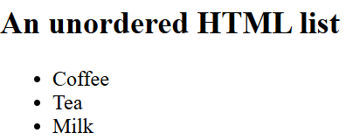
<!DOCTYPE html>
<html>
<body>

<h2>An ordered HTML list</h2>

<ol>
<li>Coffee</li>
<li>Tea</li>
<li>Milk</li>
</ol>

</body>
</html>
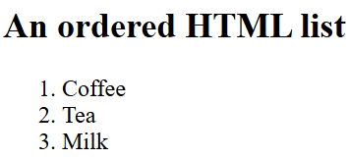

(a) Numbers (default)
<ol type="1">
<li>Item</li>
</ol>
Output: 1, 2, 3…

(b) Lowercase letters
<ol type="a">
<li>Item</li>
</ol>
Output: a, b, c…

(c) Uppercase letters
<ol type="A">
<li>Item</li>
</ol>
Output: A, B, C…

(d) Lowercase Roman numerals
<ol type="i">
<li>Item</li>
</ol>
Output: i, ii, iii…

(e) Uppercase Roman numerals
<ol type="I">
<li>Item</li>
</ol>
Output: I, II, III…

2. Starting the List from a Custom Number
Use the start attribute:
<ol type="1" start="5">
<li>Item</li>
</ol>
Output:
5. Item
6. Item
7. Item

3. Reversing the Numbering
Use:
<ol reversed>
<li>Item</li>
</ol>
Output:
3. Item
2. Item
- Item

Type | Example | Output
type="1" | numbers | 1, 2, 3
type="a" | lowercase letters | a, b, c
type="A" | uppercase letters | A, B, C
type="i" | lowercase Roman | i, ii, iii
type="I" | uppercase Roman | I, II, III

<!DOCTYPE html>
<html>
<body>
<table border="1">
<tr>
<th>ID</th>
<th>Name</th>
<th>Age</th>
<th>City</th>
</tr>
<tr>
<td>1</td>
<td>Alice</td>
<td>24</td>
<td>New York</td>
</tr>
<tr>
<td>2</td>
<td>Bob</td>
<td>30</td>
<td>Los Angeles</td>
</tr>
</table>
</body>
</html>
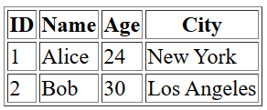
<!DOCTYPE html>
<html>
<style>
div {
background-color: yellow;
}
</style>
<body>

<h1>HTML DIV Example</h1>

<div>
<h2>London</h2>
<p>London is the capital city of England.</p>
<p>London has over 13 million inhabitants.</p>
</div>

<p>The yellow background is added to demonstrate the footprint of the DIV element.</p>

</body>
</html>
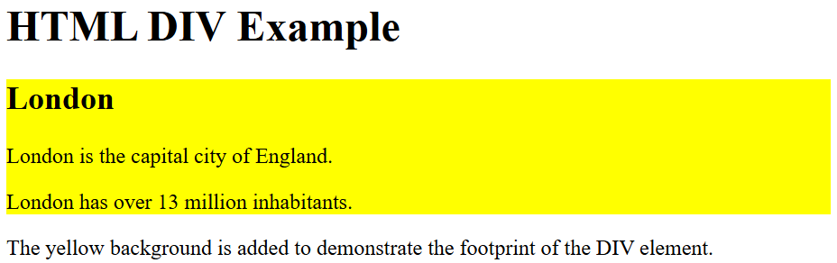
<!DOCTYPE html>
<html>
<body>

<h1>Multiple DIV Elements</h1>

<div style="background-color:yellow;">
<h2>London</h2>
<p>London is the capital city of England.</p>
<p>London has over 13 million inhabitants.</p>
</div>

<div style="background-color:green;">
<h2>Oslo</h2>
<p>Oslo is the capital city of Norway.</p>
<p>Oslo has over 600.000 inhabitants.</p>
</div>

<div style="background-color:blue;">
<h2>Rome</h2>
<p>Rome is the capital city of Italy.</p>
<p>Rome has almost 3 million inhabitants.</p>
</div>
</body>
</html>
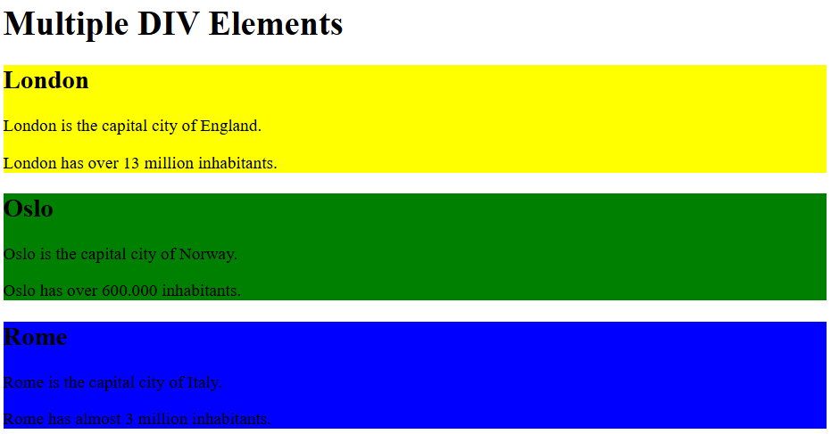
<!DOCTYPE html>
<html>
<style>
div {
width: 300px;
margin: auto;
background-color: yellow;
}
</style>
<body>
<h1>Center align a DIV element</h1>
<div>
<h2>London</h2>
<p>London is the capital city of England.</p>
<p>London has over 13 million inhabitants.</p>
</div>

</body>
</html>
<!DOCTYPE html>
<html>
<body>

<h1>The span element</h1>
<p style="color:blue;">My mother has blue eyes</p>
<p>My mother has <span style="color:blue;">blue </span>eyes </p>

</body>
</html>
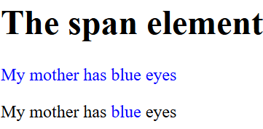
School Time Table

<!DOCTYPE html>
<html lang="en">

<body>
<table border="1" cellspacing="0">

<th colspan="6">Time Table</th>

<tr>
<th rowspan="6">Hours</th>
<th>Mon</th>
<th>Tue</th>
<th>Wed</th>
<th>Thu</th>
<th>Fri</th>
</tr>
<tr>
<td>Math</td>
<td>Science</td>
<td>Math</td>
<td>Science</td>
<td>Arts</td>
</tr>
<tr>
<td>Math</td>
<td>Science</td>
<td>Math</td>
<td>Science</td>
<td>Arts</td>
</tr>
<tr>
<th colspan="5">Lunch</th>
</tr>
<tr>
<td>Math</td>
<td>Science</td>
<td>Math</td>
<th colspan="2" rowspan="2">Project</th>
</tr>
<tr>
<td>Math</td>
<td>Science</td>
<td>Math</td>
</tr>
</table>
</body>
</html>
